PROJECT NAME : DISNEY HOTSTAR

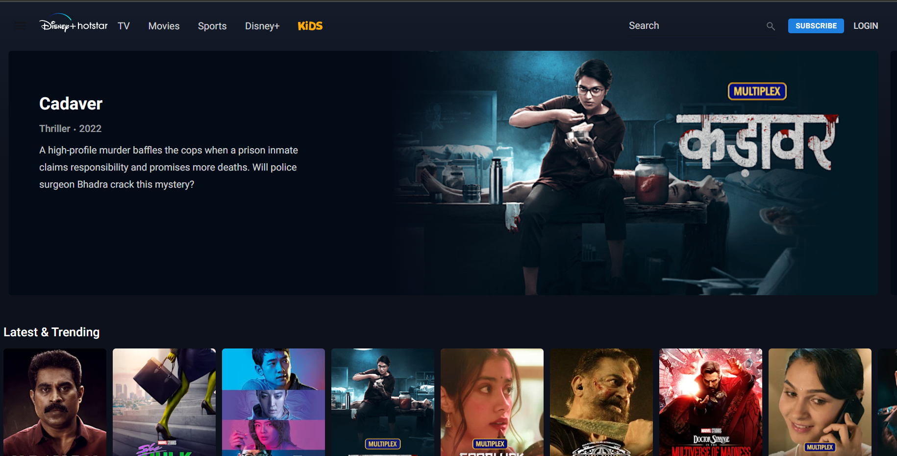

ROHAN MEHTA

Edureka Presents

OVERVIEW

### 

Disney+ Hotstar is an online video streaming platform owned by Novi Digital Entertainment Private Limited, a wholly owned subsidiary of Star India Private Limited. Disney+ Hotstar currently offers over 100,000 hours of TV content and movies across 9 languages, and every major sport covered live. Highly evolved video streaming technology and a high attention to quality of experience across devices and platforms, make Disney+ Hotstar the most complete video destination for Over The Top (OTT) video consumers

**GOALS**

* LOGIN PAGE
* SUBSCRIPTION PAGE
* PAYMENT PAGE
* STREAMING PAGE
* LOGIN AND LOGOUT PAGE

HISTORY

In the early hours of February 1st 2015, a handful of people popped open a bottle of bubbly in one corner of the 27th floor of our office in Lower Parel. We had launched the project they’d been working on for months, a digital entertainment platform called Disney+ Hotstar. In between slices of cake, they took turns refreshing their analytics page to see how many people were downloading the app. For the past few months, they’d worked countless hours, coming in at weekends, even sleeping in the office. Even as they sipped from their glasses, they knew their work wasn’t done, but for now, a moment of respite to celebrate all their efforts. Within six days the app had hit 1 million downloads, faster than any other entertainment app in the world. By the tenth day it was 2 million downloads. Over the next two years, the app would break record after record in the online entertainment space. At the time, the team behind Disney+ Hotstar had no idea of the scale of what they’d just achieved.

**Technologies Used in Hotstar:**

**Front-End:**

* **HTML**
* **CSS**
* **JAVASCRIPT**
* **REACT DYNAMIC**
* **BOOTSTRAP**

**Dynamic**

* **JAVASCRIPT**
* **CI/CD WITH AWA**
* **LOGIN AND LOGOUT (OAUTH AND JWT)**

**Database**

* **MONGODB**
* **JSON DATA**

**Code Compilers**

* **VS CODE**
* **GIT BASH**
* **GITHUB**
* **NODE JS**

**Github json link:**